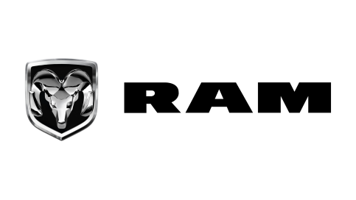


GSO Conformity Certificate CCR No. 111111
Motor Vehicles
Manufacturer: KIA CORPORATION
Country of Origin: CHINA, Country of Production: CHINA
To: GCC Standardization Organization (GSO)
We hereby certify that the vehicles manufactured by KIA CORPORATION
* Type: KIA SPORTAGE NQ5e HEV 1.5L SUV FWD 5Doors
* VlN number:
* Model Year: 2023 * Produced in and after: Month Year
* Category: Truck
Will satisfy the G50 Technical Regulations Nos: 34:20o7, 3s:2007, 36:2005, 37:2012, 38:200s, 392005, 40:2011,42:2015, 48:1984, 51:20o7, 52:2007, 53.2007, 9611988. 9721988, 9811988, 9921988,13522007, 13622007. 29021994. 4119:1994,42o:1994,421:2005,422:200s.1040:20001041:2000,1042:2000,1053:2000,1503:2010,1598:2002,1624:2002,1677:2003,1708:2o0s,1780:2010,1781:2006,1782:2008,1783:2006,1784:2o0e.Gsolso1585:2008,GSO lSO 3537:2008, GSO 150 3538:1997, G50 ECE13H:2012,GSO ECE13H-1:2012,GSO ECE13H-2:2012,GSO ECE 13H-3:2012, GSO ECE13H-4:20l2, GSO ECE13H-S:2012,GSO ECE 13H-6:2012 and the standards in the country of origin accepted by GSO in the case that no GSO technical regulations and standards are available.
All the essential technical data are as follows:
1. Weights
a. Maximum Vehicle Weight: kg b. Curb: kg
c. Maximum Axle Weight: Front: kg Rear: kg
2. Dimensions
a. Length: mm b. Width: mm
c. Height: mm d. Wheelbase (Fl R1) mm e. Track: Front: mm Rear: mm
3. Type of chassis and body: Body-on-frame
4. Number of Passengers: (Including the Driver)
5.Engine: Petrol a. Cylinders: b. Displacement: cc c. Air intake: Twin Turbo
d. Net Engine Power: kW at rpm Pollutant Limit comply with Euro 6B standards.
6. Transmission: Automatic
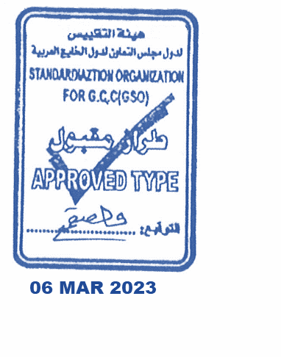
7. Brakes a. Service Brakes: Hydraulic b. Emergency Brakes: Combined with the service brake
8. Fuel Economy a. Motor Vehicle Class: Light Truck b. FE (CAFE) Combined: 09. km/L - Poor
9. Any other information or local standards to be compiled: for member countries mentioned in the Annex of the list of Technical Regulations for MV 2025 MY-D3, when exporting to those countries.

17 SEP 2025

